Australian GDP Performance

Available data from Organization for Economic Co-operation and Development (OECD) allows for a comparative analysis on how the Australian quarterly GDP performs over the years. Australia holds the current record worldwide as the economy with the longest economic growth among developed countries.

How GDP growth rate is calculated?

GDP is calculated first on a quarterly basis with the following formula:

Quarter-on-quarter GDP Growth Rate = (Current Qtr GDP – Previous Qtr GDP)/Previous Qtr GDP

The resulting growth rate for the quarter is then annualized using the following formula:

Growth Rate = [ (1 + Quarter-on-quarter GDP Growth Rate)4 – 1 ] \* 100

The resultant Growth Rate is rounded 1 decimal number. GDP Growth rate is a quick indicator on how the country’s economic performance compares with the previous quarter and with the same quarter the previous year.

Calculating GDP

There are several so-called approaches in calculating GDP. These are the Output Approach, Expenditure Approach, and the Income Approach. Output Approach is characterized by computing the GDP using the total value of goods and services produced by the country. The Expenditure Approach uses government spending, consumption, net exports and investments whilst Income Approach measures the GDP by the total income generated in producing goods and services.

Australian GDP is calculated as:

GDP = C (Private Consumption) + I (Private Investment) + G (Government Expenditure) + (EX – IM)

where EX stands for export of goods and services and IM stands for import of goods and services.

Australian GDP Data Exploration

For our group, the Skeptics, we decided to use the Expenditure Approach as the GDP method by which we work on this paper. We sourced our data from OECD. Annual and quarterly GDP data from 1960 for all the 3 GDP approaches are available in OECD. For the purpose of comparing Australian GDP vs the top 10 OECD member economies, we used the GDP Expenditure Approach data. GDP data of Canada, Spain, UK, Ireland, Japan, South Korea, The Netherlands, France, and USA were chosen for comparison with Australia. It is worth mentioning that on this research, we are using the Expenditure Approach data only, which may not show exactly the same figures or results as that of the other approaches in terms of GDP behaviors or performance measurement. Secondly, that continuous periods of positive or negative growth vary when using one over the other approaches.

Counting all the quarter periods with uninterrupted positive growth for the 10 countries from 1960, Table 1 shows that Australia emerged as the country with the most positive growth periods.

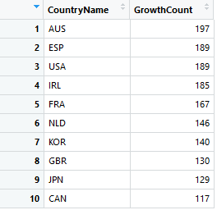

Table 1: Continuous Growth Periods (Data Source: OECD)

Graph 1 shows the bar chart on the most number of consecutive periods or quarters the countries enjoyed uninterrupted GDP growth.

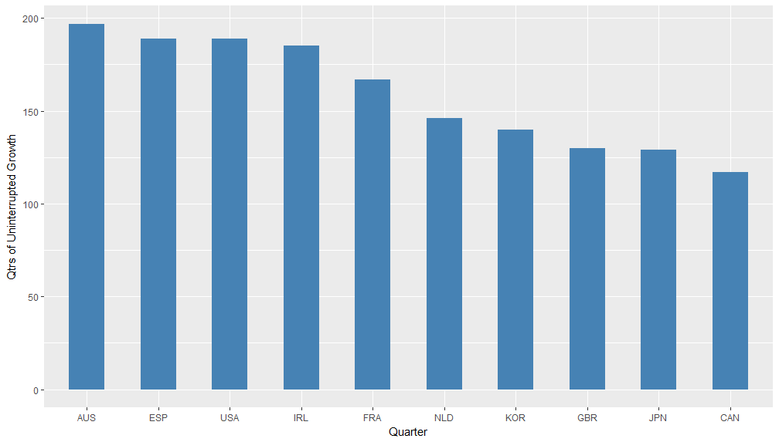

Graph 1: Periods of uninterrupted growth of 10 countries (Data Source: OECD)

Australian GDP Performance

Graph 2 shows the GDP growth performance of 10 countries including that of Australia (highlighted in red). The Australian economy has shown to be resilient during the past two decades. Australia was able to weather the many global economic crisis including the Asian crisis of 1997-1998. Gone through the US stock market crash and recession of 2001 and performed well above others during the Global Financial crisis (GFC) of 2009. Australia’s impressive economic performance in the past two decades has been a result of recent economic reforms, booming mining sector, and a strong population growth rate.

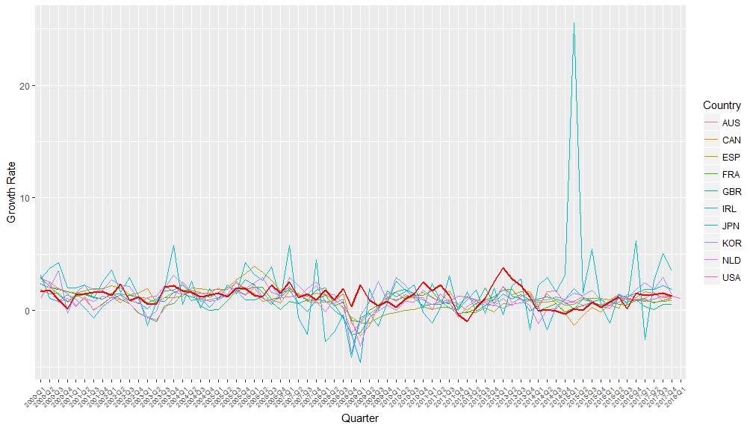

Graph 2: GDP growth of 10 countries from 2000 - 2017 (Data Source: OECD)